# SPRINT DELIVERY 3

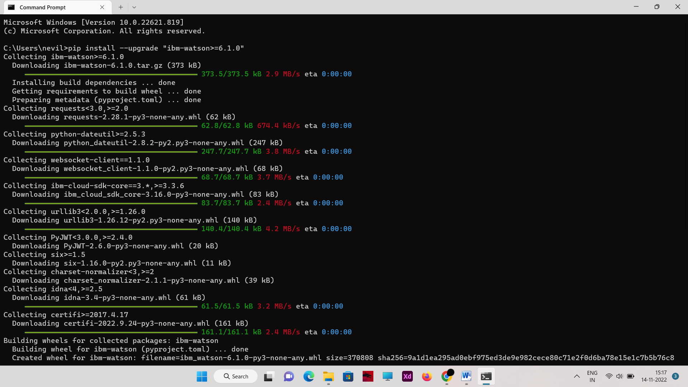

TEAM ID: PNT2022TMID19437

ESTABLISHING THE TEXT-TO-SPEECH SERVICE

1. **INSTALLATION OF WATSON VERSION: CODE:**

pip install --upgrade "ibm-watson>=6.1.0"

RESULT:

1. **COPYING CREDENTIALS FOR API AND URL:**

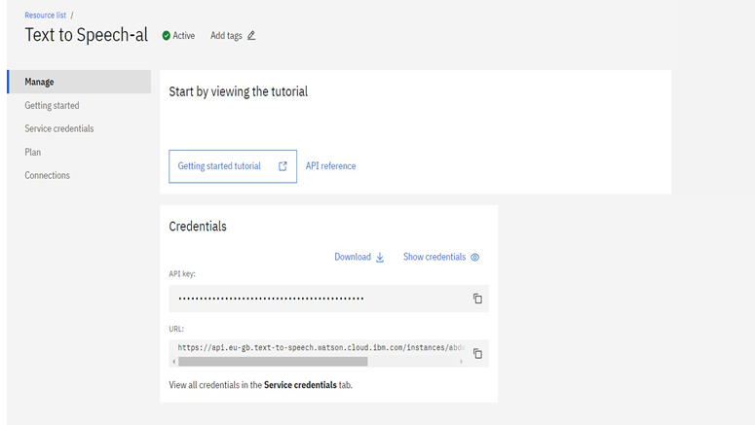

**PROGRAM FOR ACESSING APIs OF TTS SERVICE:** from ibm_watson import TextToSpeechV1

from ibm_cloud_sdk_core.authenticators import IAMAuthenticator

authenticator = IAMAuthenticator('7NcRcpMT221nhk1kB5DTsWpK- GQgjKFaWKa7Ao1BU7zQ')

text_to_speech = TextToSpeechV1( authenticator=authenticator

)

text_to_speech.set_service_url('https://api.eu-gb.text-to- speech.watson.cloud.ibm.com/instances/e7133289-0146-4193-a7d5- b354d6831556')

with open('para.wav', 'wb') as audio_file: audio_file.write( text_to_speech.synthesize(

'its the time to take paracetomal',

voice='en-US_AllisonV3Voice', accept='audio/wav'

).get_result().content)